**Table of Contents**

STUDENT ROLE 2

* 1. SIGN-UP 2

Sign-up Description: 2

* 1. SIGN-IN 2

Sign-in Description: 3

* 1. BECOME A PARTNER FLOW 3

Become a Partner Description: 4

* 1. PROFILE DASHBOARD FLOW 4

Profile Page Description: 6

* 1. MEMBERSHIP AND CREDITS FLOW 7

Membership and Credit Flow Description: 8

* 1. COURSE ENROLLMENT FLOW 9

Course Enrolment Description: 10

* 1. EVENT REGISTRATION FLOW 10

Event Registration Description: 11

* 1. EXPERIENCE REEGITRATION FLOW 11

Experience Registration Description: 12

* 1. QUIZ FLOW 12

Quiz Flow Description: 14

TEAM ADMIN ROLE 14

# STUDENT ROLE

## SIGN-UP

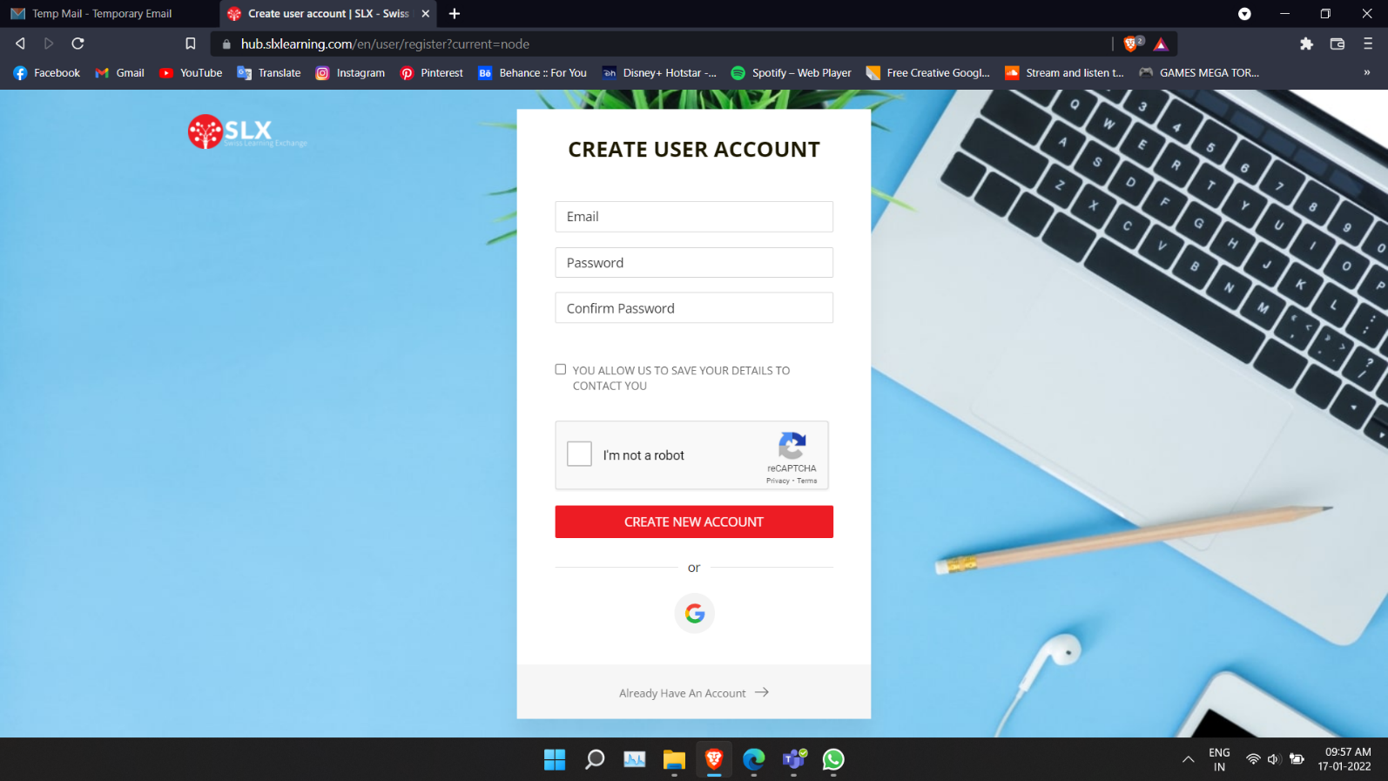

Figure 1

### Sign-up Description:

User will be able to get this page by click the Sign-up button in the home page. The User must provide the information in the field of Email, Password, Confirm Password and can check the Contact you check box to receive the future updates via mail. Users must verify them with Google reCAPTCHA. When the Create New Account is clicked with all the user provided information is correct then it will create a new account for the user and user will receive email for the confirmation for the New User. User can also Create a New Account with the google sign-up option by clicking the google button it will leads to google login page. If the User already has an account, then user can click the Already have an account link and it will redirect to the Sign-In page.

## SIGN-IN

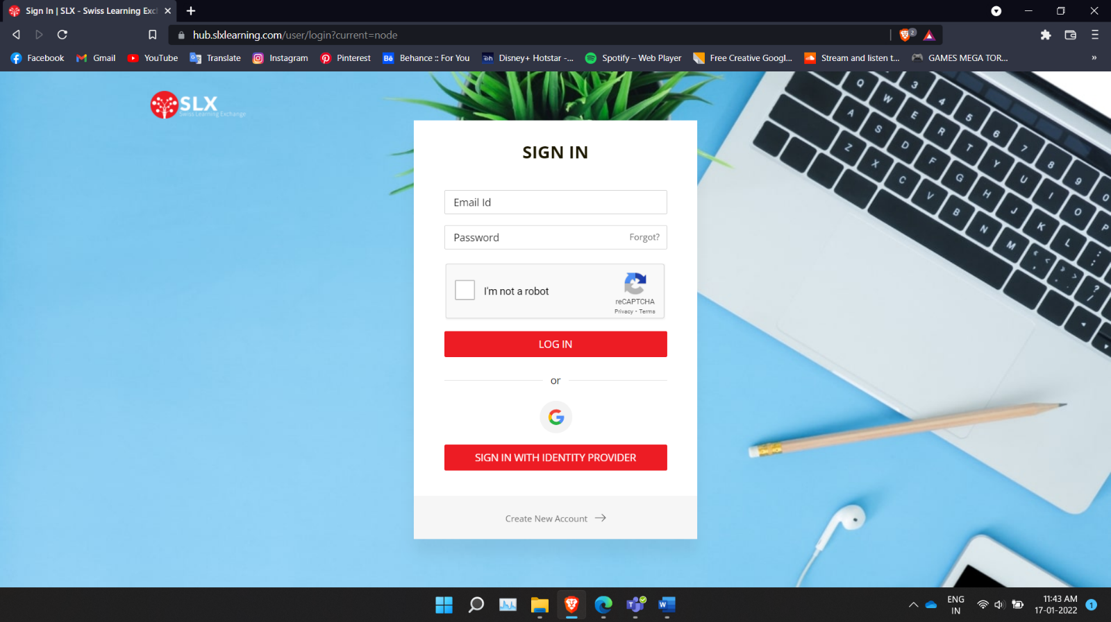

Figure 2

### Sign-in Description:

User will be able to get this page by click the Sign-in button in the home page. The User must enter their Email, Password to access the page. User must verify them with Google reCAPTCHA, while they are login into their account. If in case user forget password, they can tap on forgot option to get new password. At that time, they need to enter their registered Email id. And, they have other option to login, that is google auto sign in. And user also can use sign in with identity provider. If in case user is not an existing user then can create the new account.

## BECOME A PARTNER FLOW

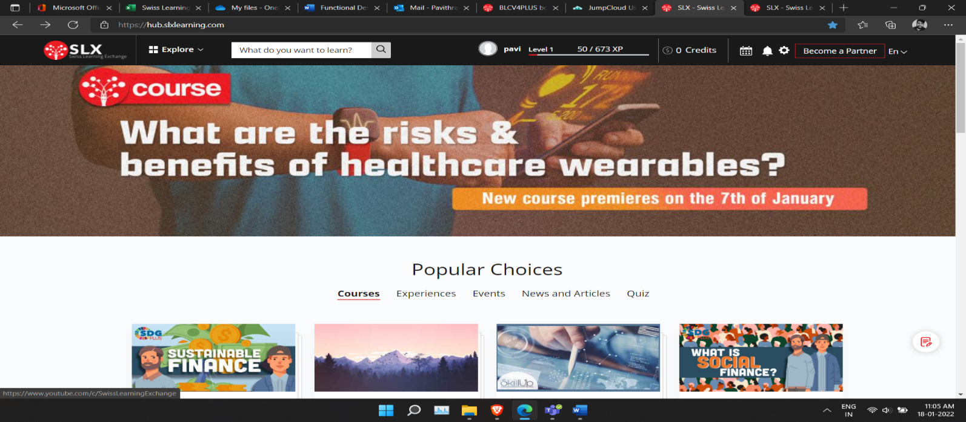

Figure 3

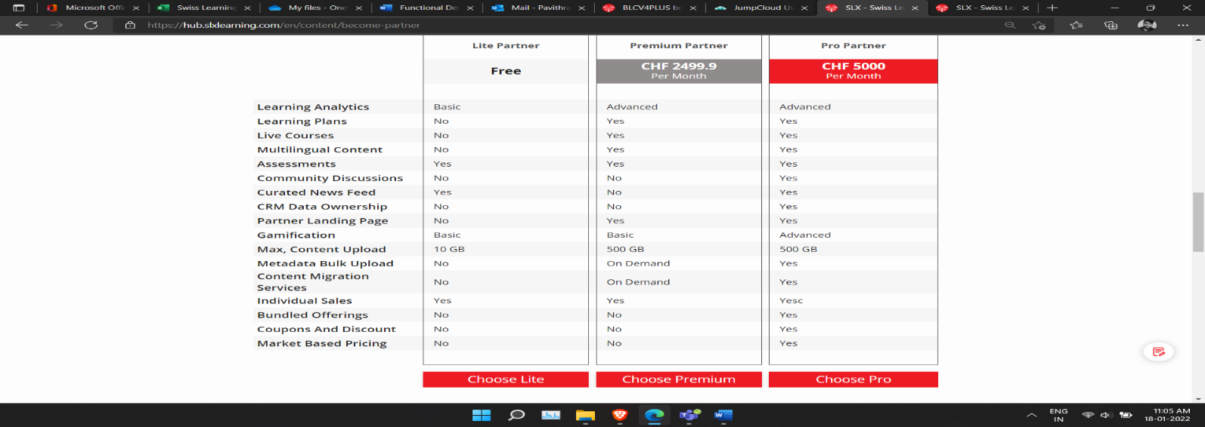

Figure 4

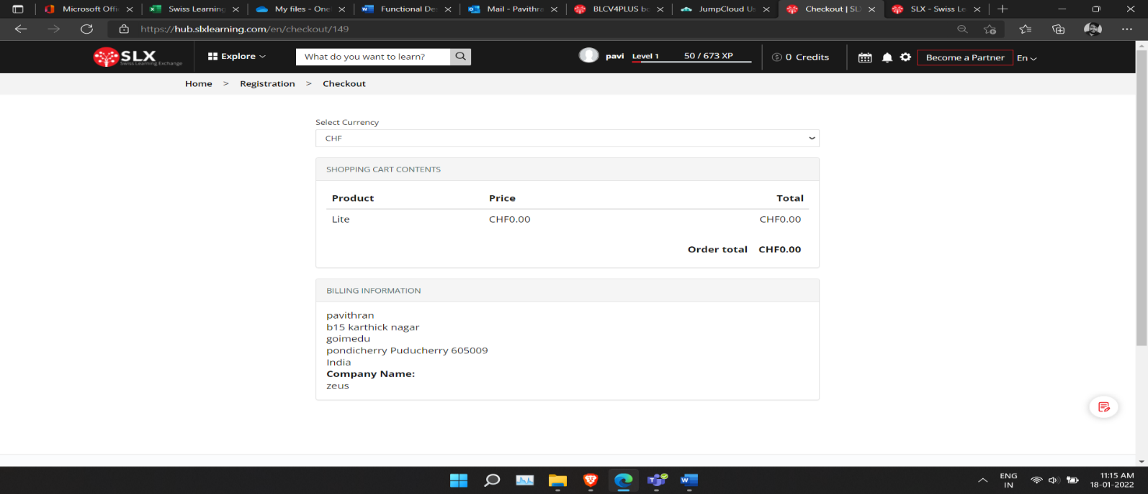

Figure 5

### Become a Partner Description:

User can be a partner with the SLX learning Hub. If a user wants to become a partner in the SLX learning they can access the become a partner option in the header of the home page after the login. It will redirect to the become a partner page, in that there are three plans for a user to become partner (Lite, Premium, Pro). Lite plan is a free plan with limited access and the premium and pro plans are monthly paid plans.

The User can select a plan and after click the Choose plan button it will redirect to the plan checkout page. In the checkout page there is option to change the currency type (CHF, INR, USD) we can select either one of these and the plan which the user selected will be displayed in that page. The user should fill the billing details for further communication and after filling that details user will click the continue to next page button to select the payment option and payment type or they can cancel the process by clicking the cancel button. The user can pay using the PayPal or by Module payment and then the user must wait for the confirmation email from the admin side and then the user can be a partner.

## PROFILE DASHBOARD FLOW

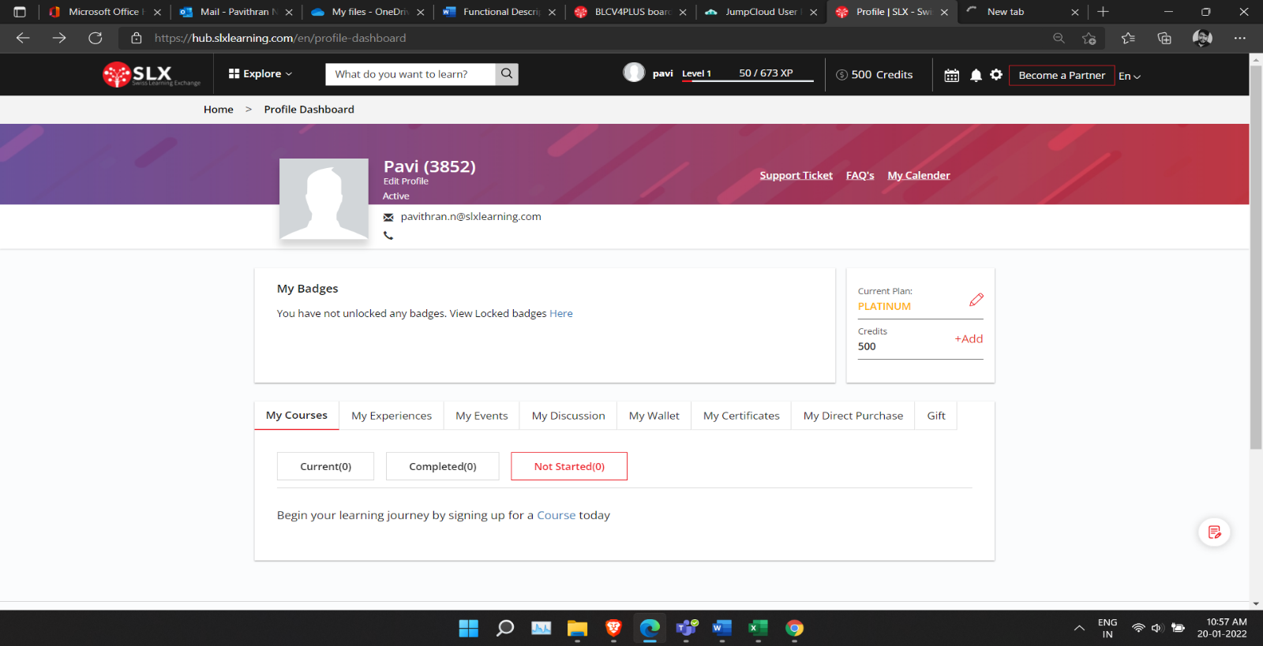

Figure 6

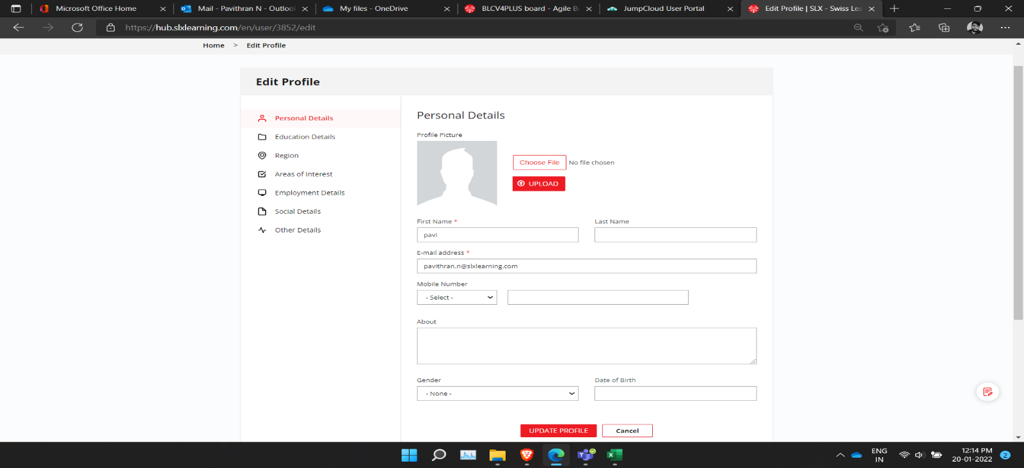

Figure 7

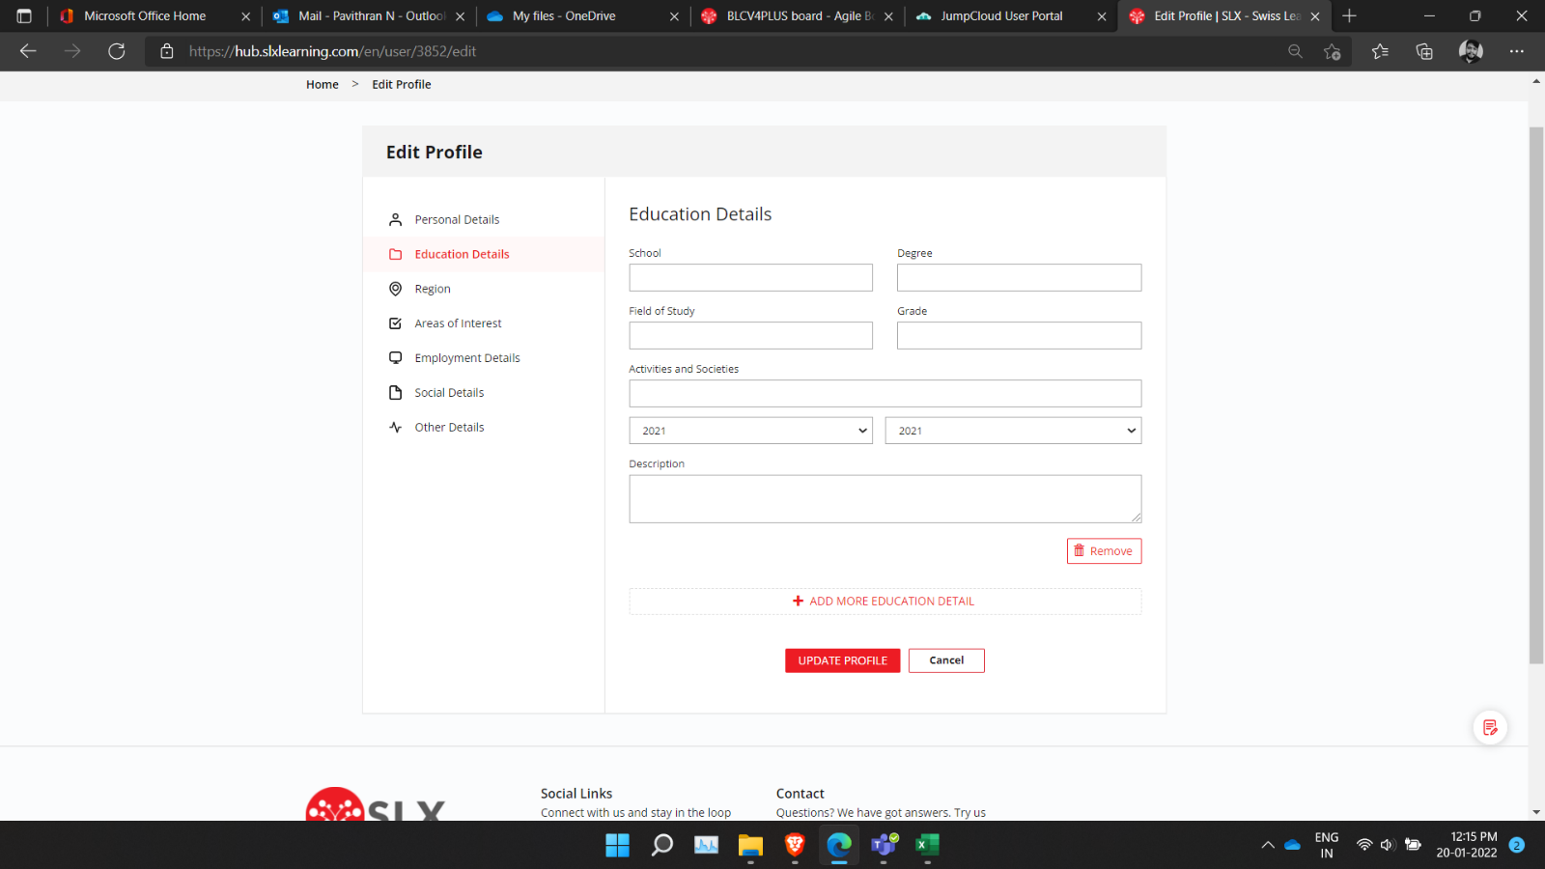

Figure 8

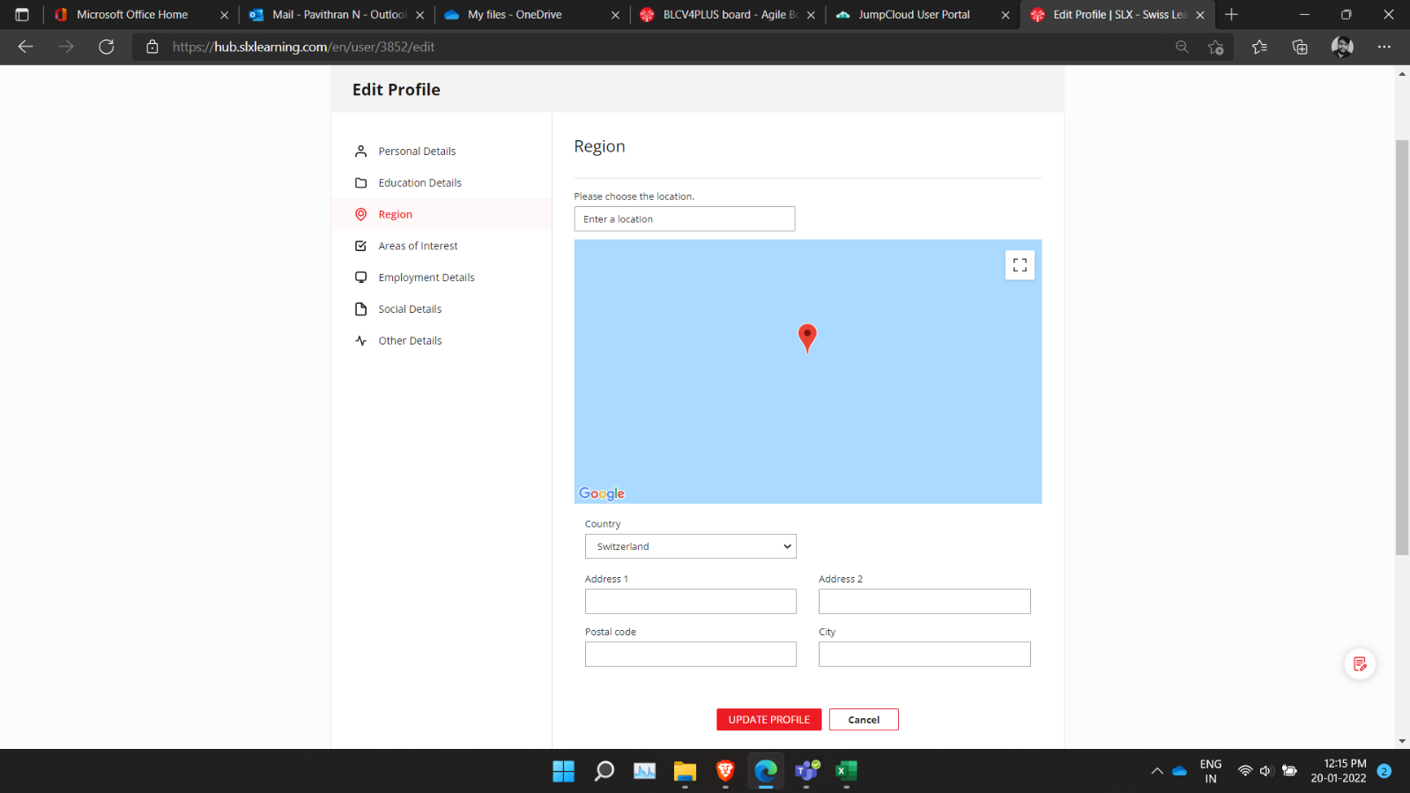

Figure 9

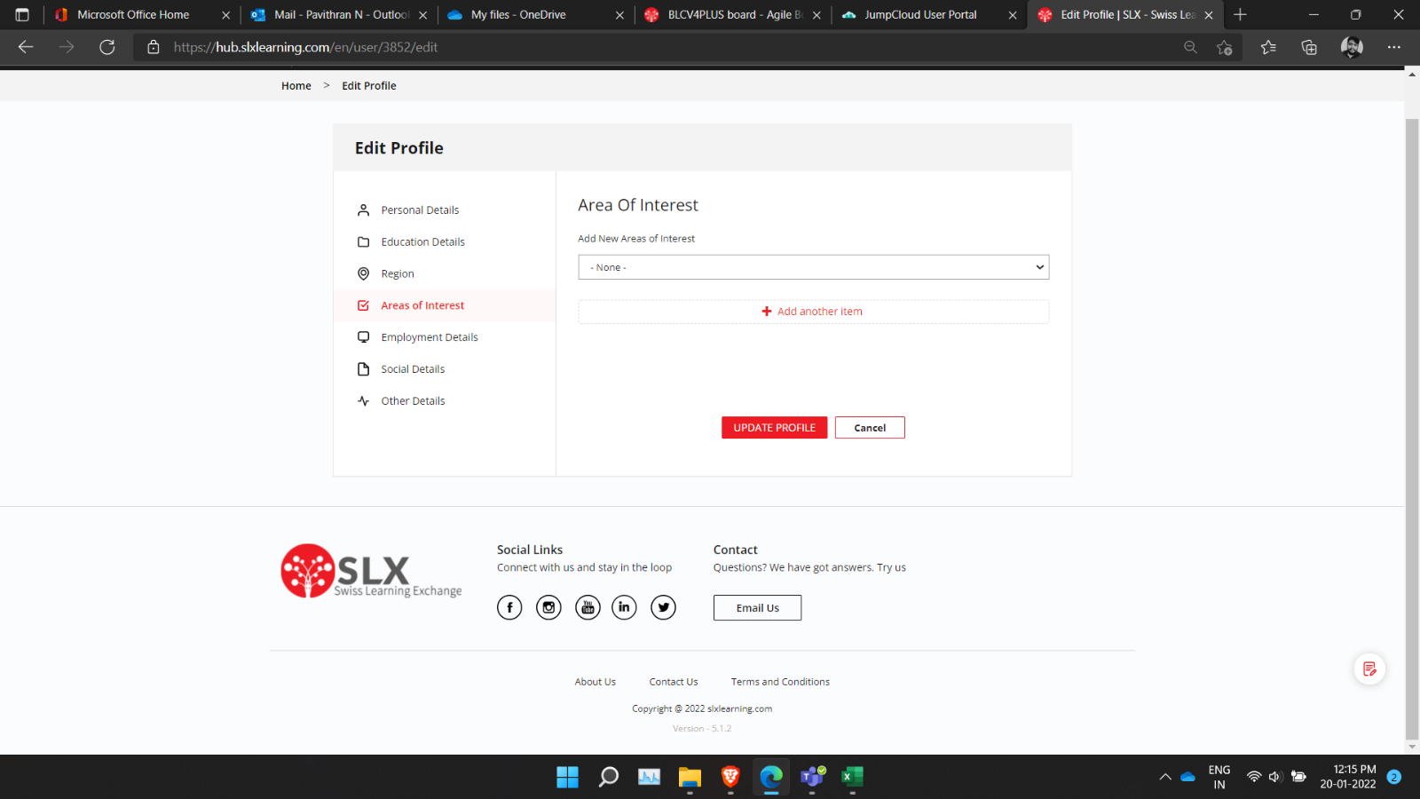

Figure 10

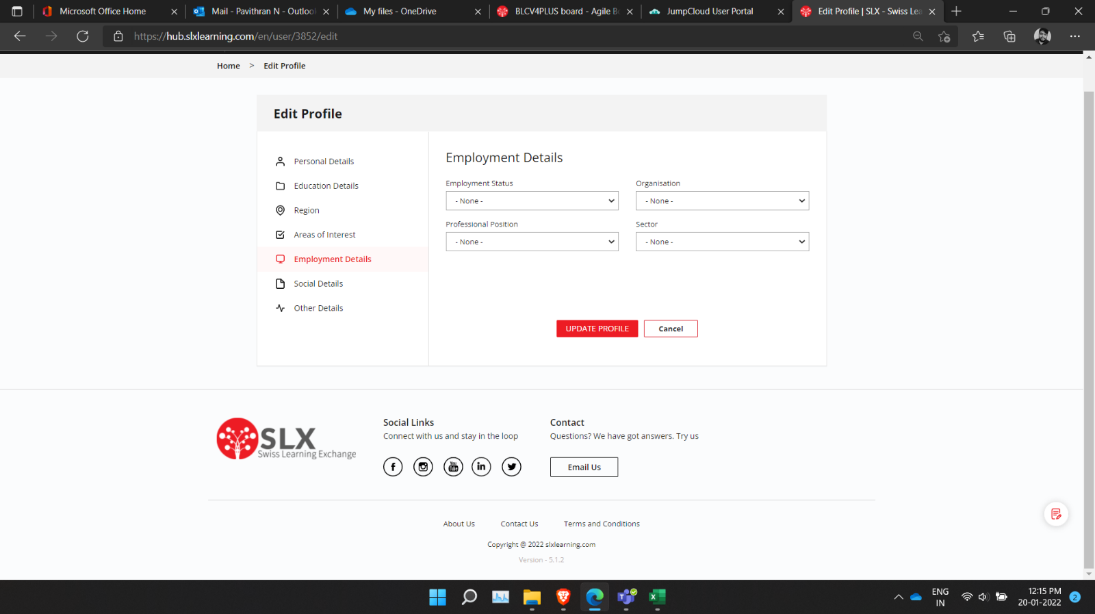

Figure 11

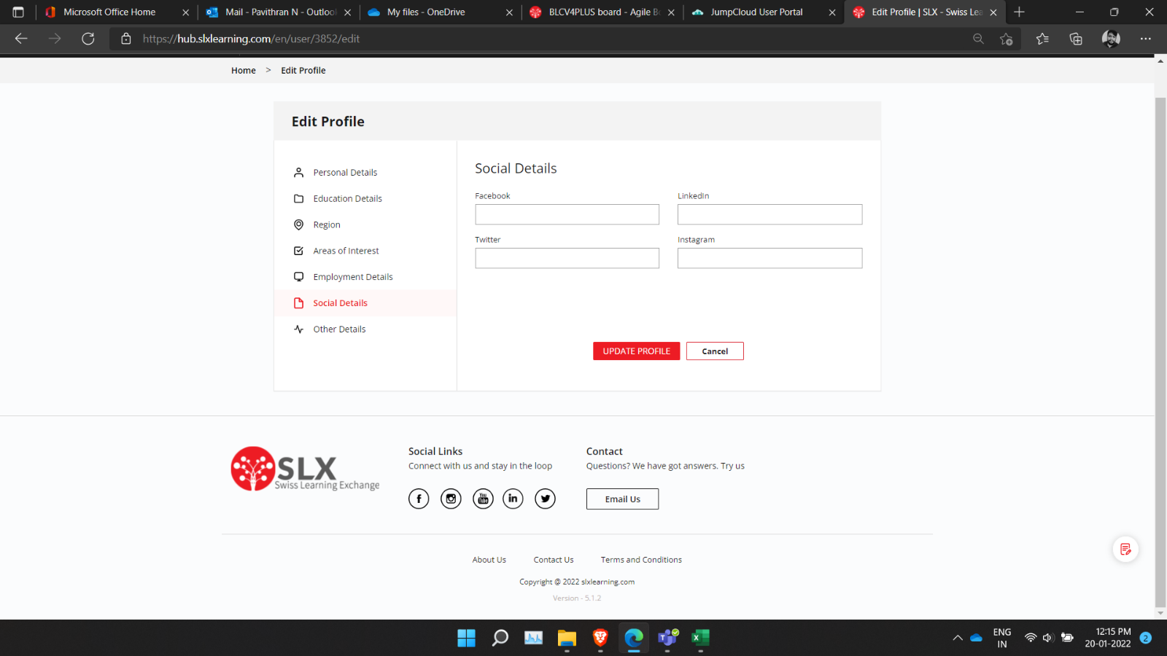

Figure 12

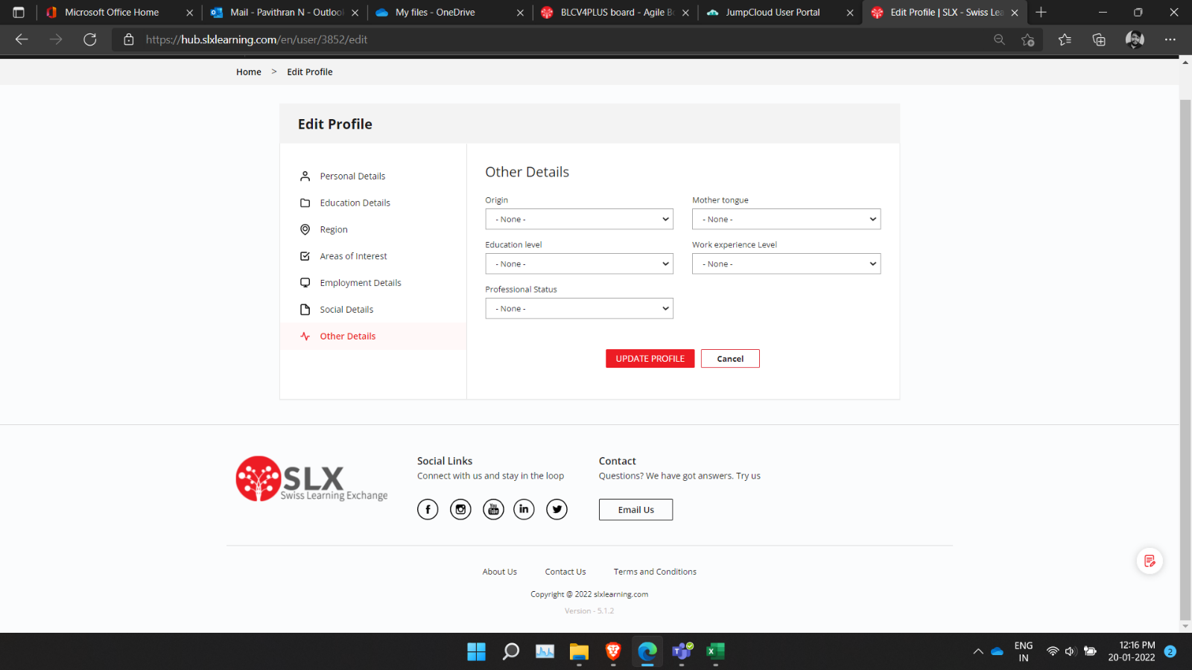

Figure 13

### Profile Page Description:

In the profile page user can see their courses, events, discussion, wallet, certificate, purchase, and gifts. For courses and events user also can see how many courses that they complected, what all are current events and courses are and what all events and courses that not yet started. And it also shows all the discussion and their wallet which include purchased credits & spent credits, certificates, and gifts.

User also can edit their profile, that include their personal information and updating profile photo, about and even they can upload their education details or even they can delete their information and they also can provide description. And with the add more option users can add more about their education. And users also can edit their address details on their area of interests, social platforms, Employment details and others like their origin, mother tongue, work experience and Professional status and all.

Users also can use calendar option; with that they can see all their upcoming events and courses. Their itself users also can use filters to check which type of course they want.

## MEMBERSHIP AND CREDITS FLOW

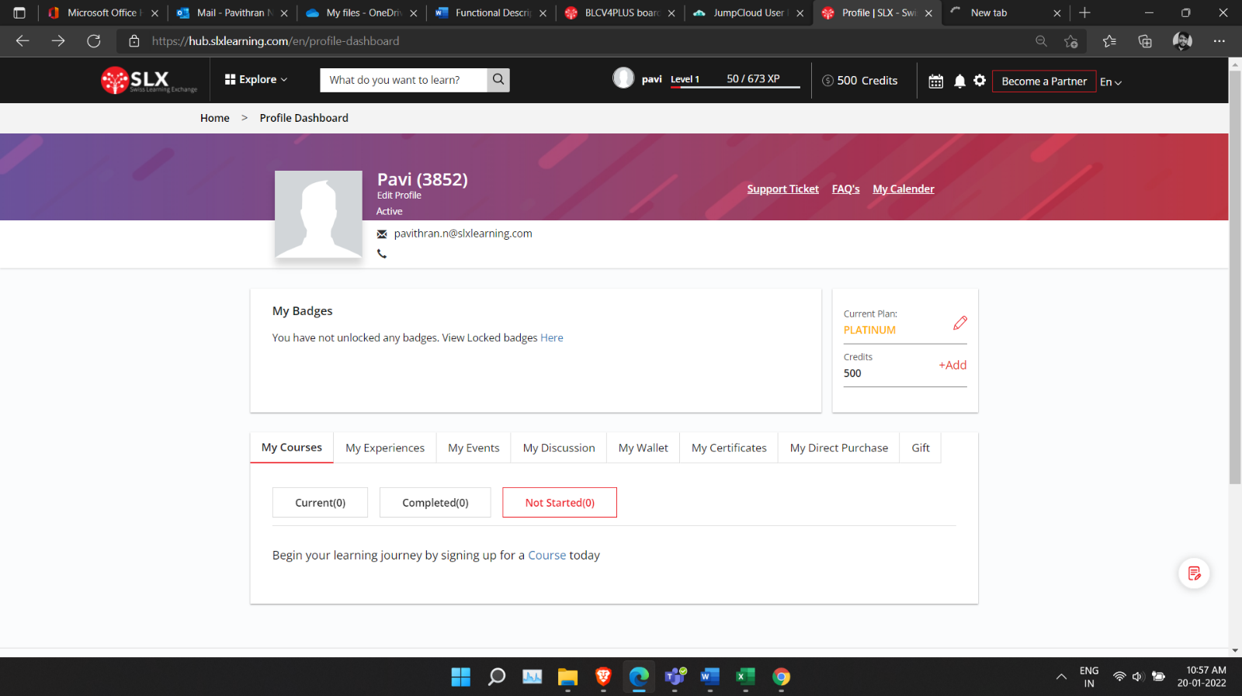

Figure 14

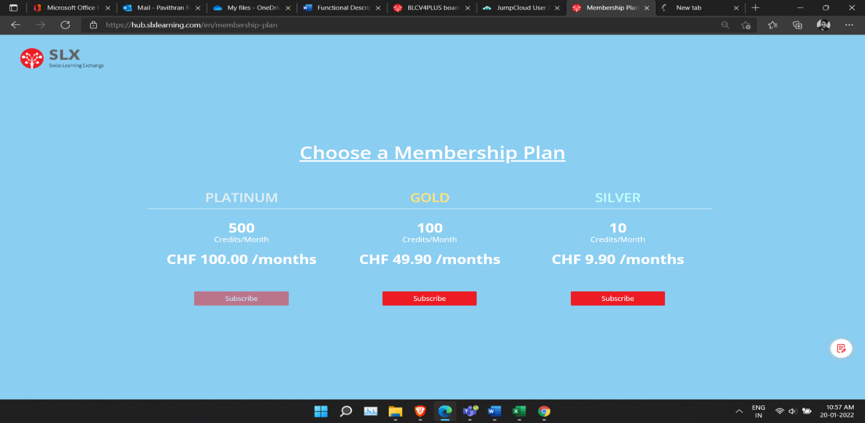

Figure 15

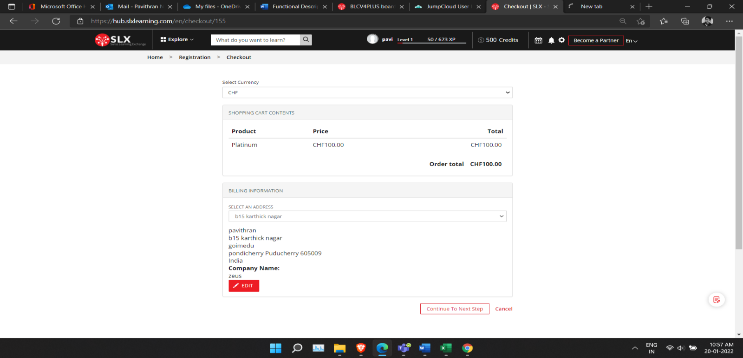

Figure 16

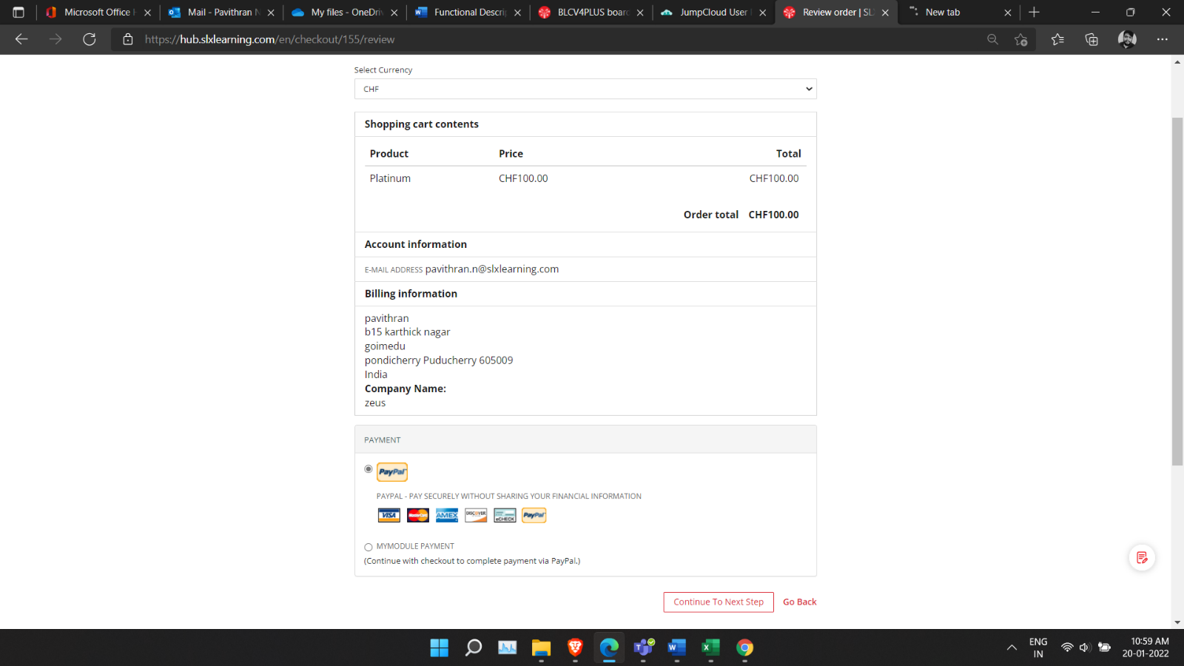

Figure 17

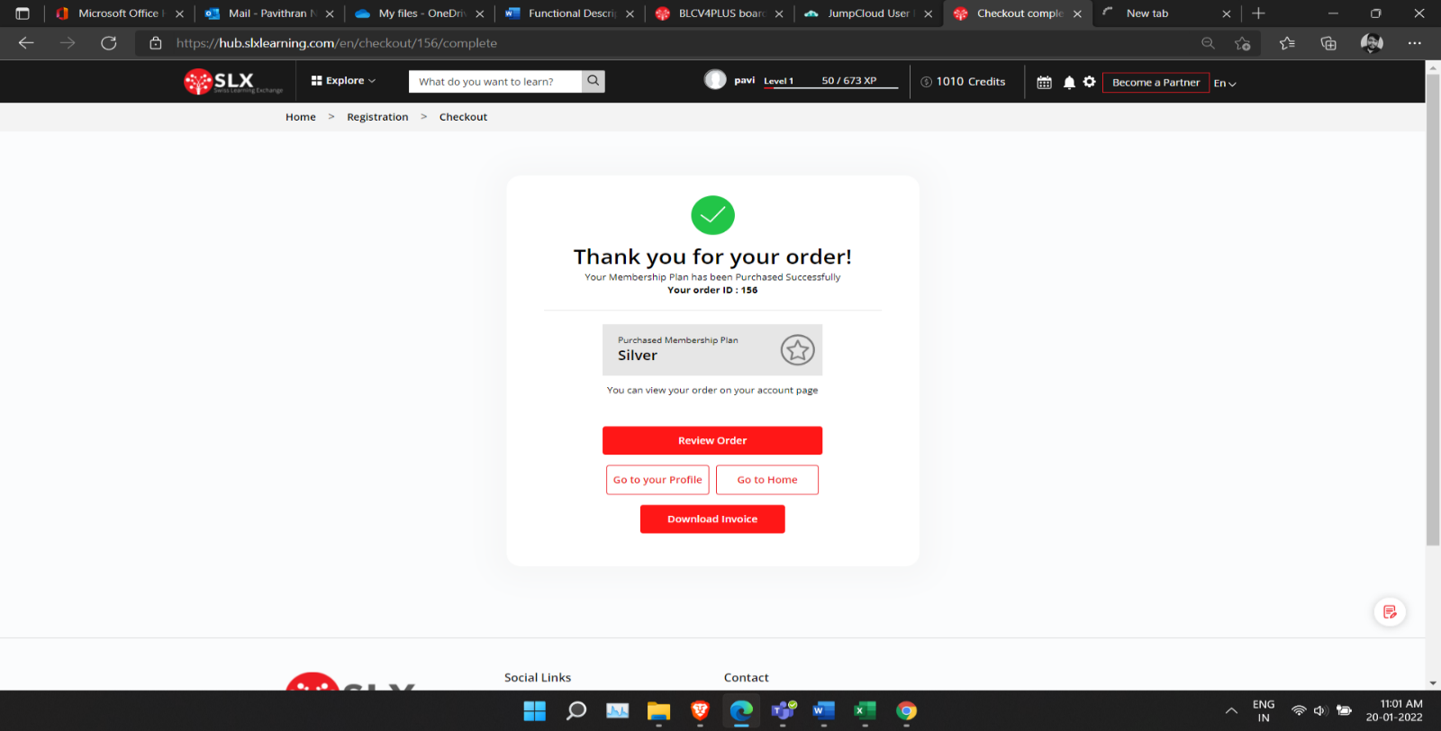

Figure 18

### Membership and Credit Flow Description:

Membership and Credits can be purchased by user by selecting the edit button on the membership module in the profile dashboard. Membership in the SLX learning provides number of credits to your account according to the plan that user selects, and the credits are used to purchase course, events, and experiences instead of purchasing by money via PayPal. Membership in the SLX learning provides number of credits to your account according to the plan that user selects, and the credits are used to purchase course, events, and experiences instead of purchasing by money via PayPal.

When the user clicks the edit button on the membership module it will redirect to the membership selection page and there are Platinum, Gold and Silver membership plans. If the user selects the plans and click the subscribe button then it will take to the plan checkout page. In the checkout page there is option to change the currency type (CHF, INR, USD) we can select either one of these and the plan which the user selected will be displayed in that page. The user should fill the billing details for further communication and after filling that details user will click the continue to next page button to select the payment option and payment type or they can cancel the process by clicking the cancel button.

The user can pay using the PayPal and after the payment is successful it will show a successful message page. In the page user can review the order but clicking the review order button and can download the receipt for the purchased membership.

## COURSE ENROLLMENT FLOW

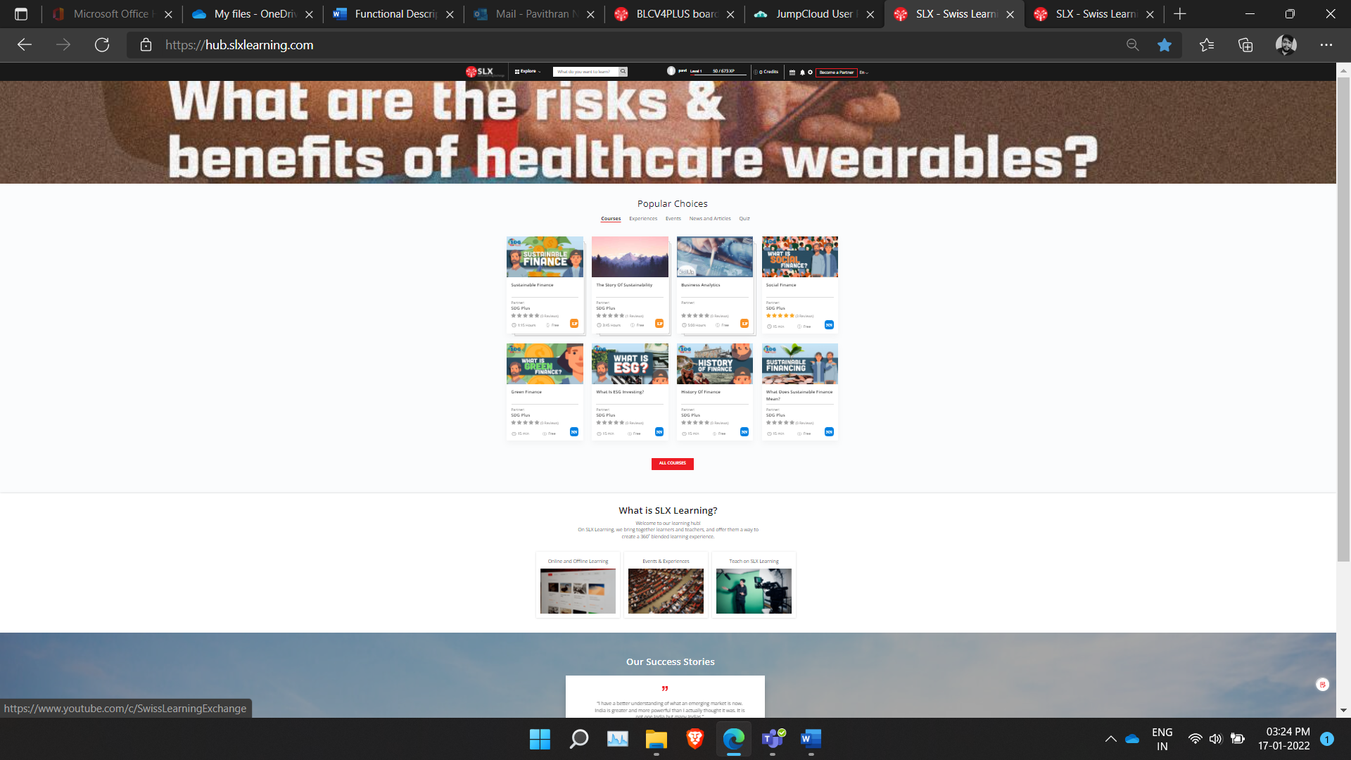

Figure 19

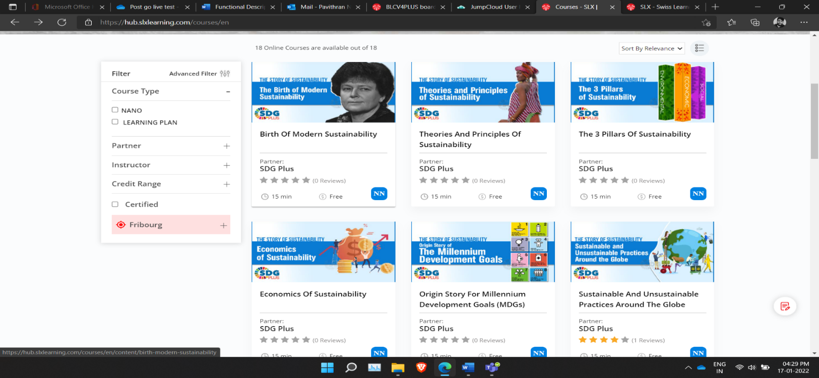

Figure 20

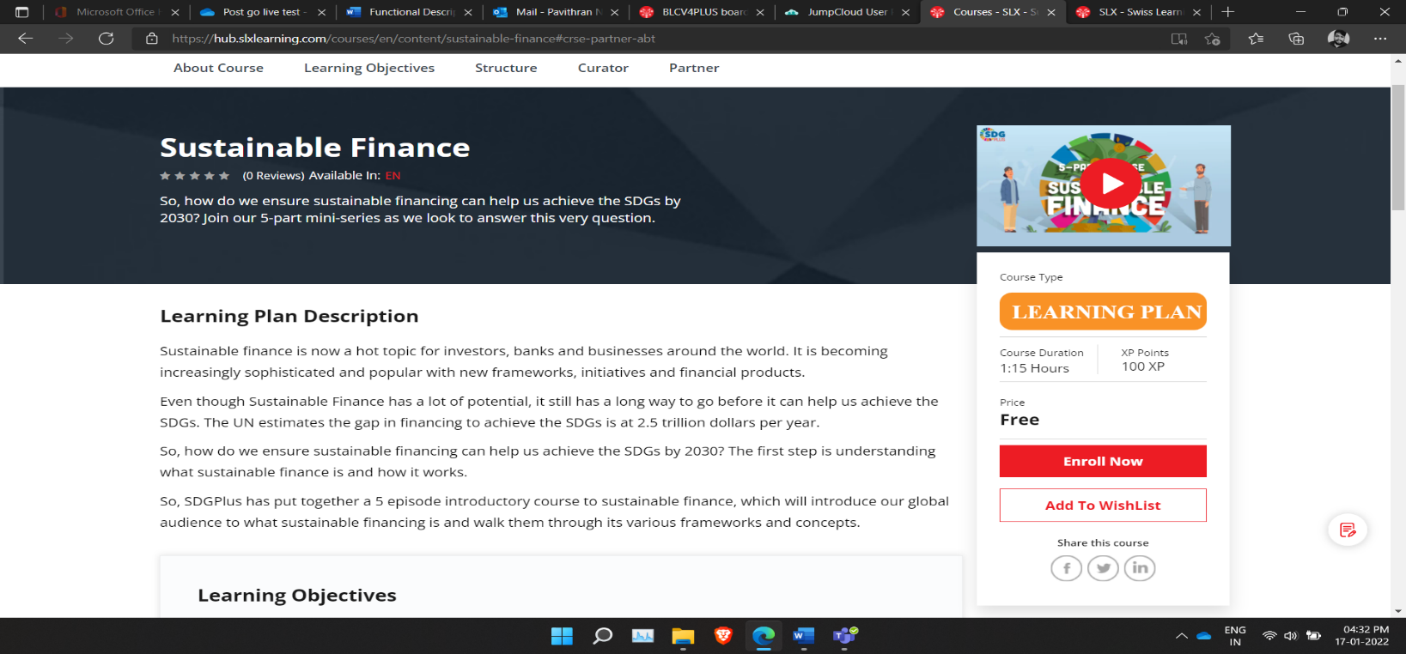

Figure 21

### Course Enrolment Description:

User can choose courses in the course module. And each course has it time and either course is free or payable also shown. Along with that user can see the rating and reviews for each course, and it is also showing partner for each course. Before user enrolling the course, it gives all kinds of basic information for user to enrol it.

  If user want to see more courses, then he needs to click on all course's buttons. Then it will be led to another page where user can find all the courses that is available in the application and there are filters, like types of courses, partner, instructor, credit range, certificate and distance and user can check in box to find what kind of courses users want. And with the help of dropdown user also can sort the courses rating, instructor rating and sort by relevance. This is for users to find courses in easy and best way.

Once user enrol a course it will show which type of course is that and user also can share the same course in social platforms like LinkedIn, fb, and twitter. And user also can add it in wish list or enrol course at that moment itself. And there is a preview video also available for user to know a bit more about the course. And here user can see their curator and about curator, partner, and their LinkedIn profile link.

## EVENT REGISTRATION FLOW

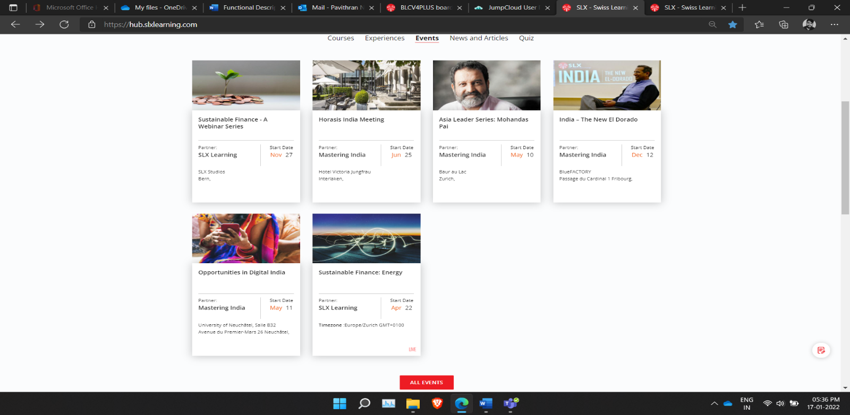

Figure 22

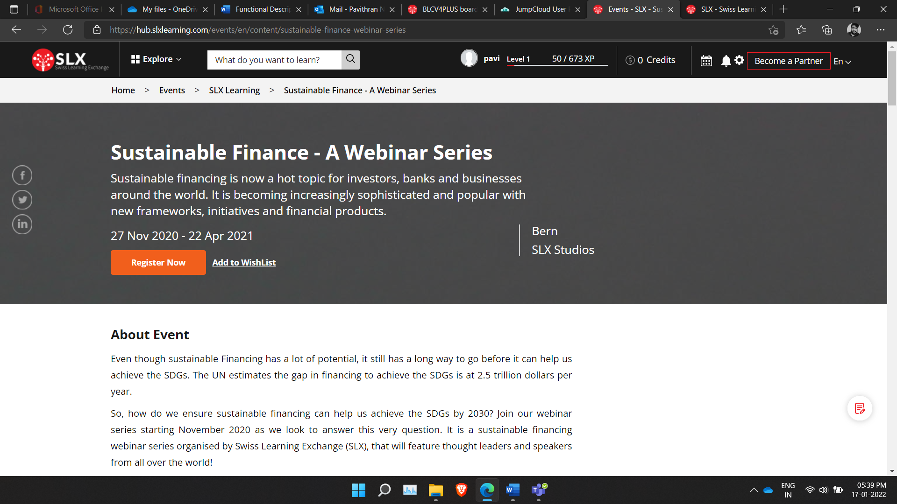

Figure 23

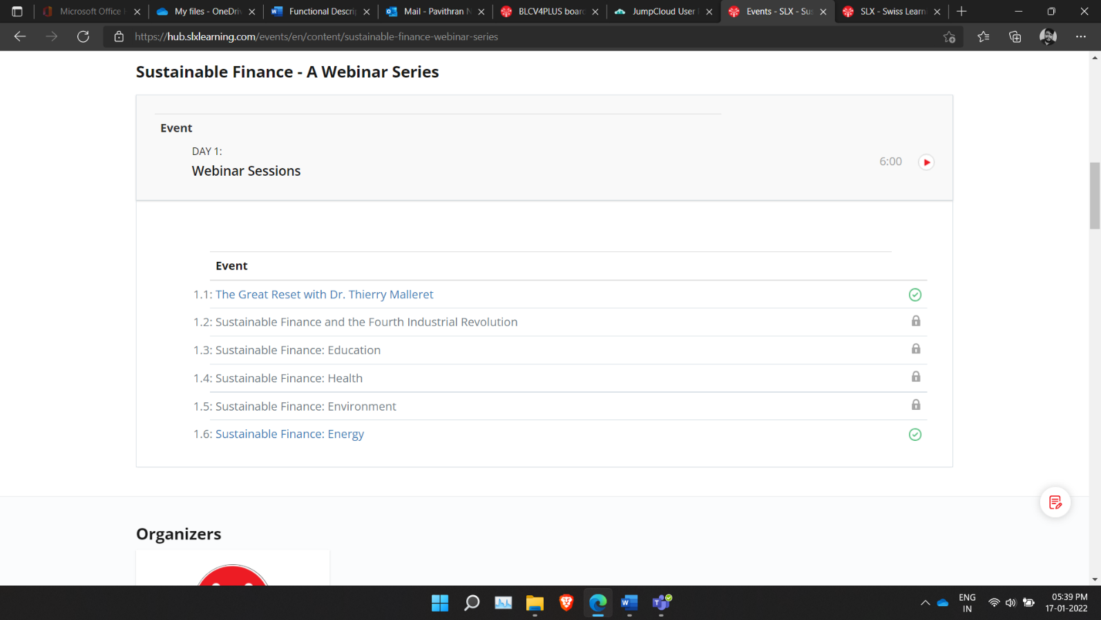

Figure 24

### Event Registration Description:

User can access the event module in the home page, there are events present in the home page and we can select the newly updated events. User can also see all the event listed in the event listing page by clicking the All Events button and it will redirect to the event listing page. To select a particular Event user can use the filter option like event type, organizers, partners, and instructors to filter out specific events. Once the event is selected in that page it will redirect to the event page.

In the event page user can see the partners, instructor’s details, and details description about that event. User can be able to register for the event by clicking the register button and if user want to register later, they can click the add to Wishlist button to add the event in the account Wishlist. Once the user registration is confirmed the user will receive a conformation email for the event registration. The user can access the several sessions in the event on the date given for that session and other session will be unlocked during the date of that session.

## EXPERIENCE REEGITRATION FLOW

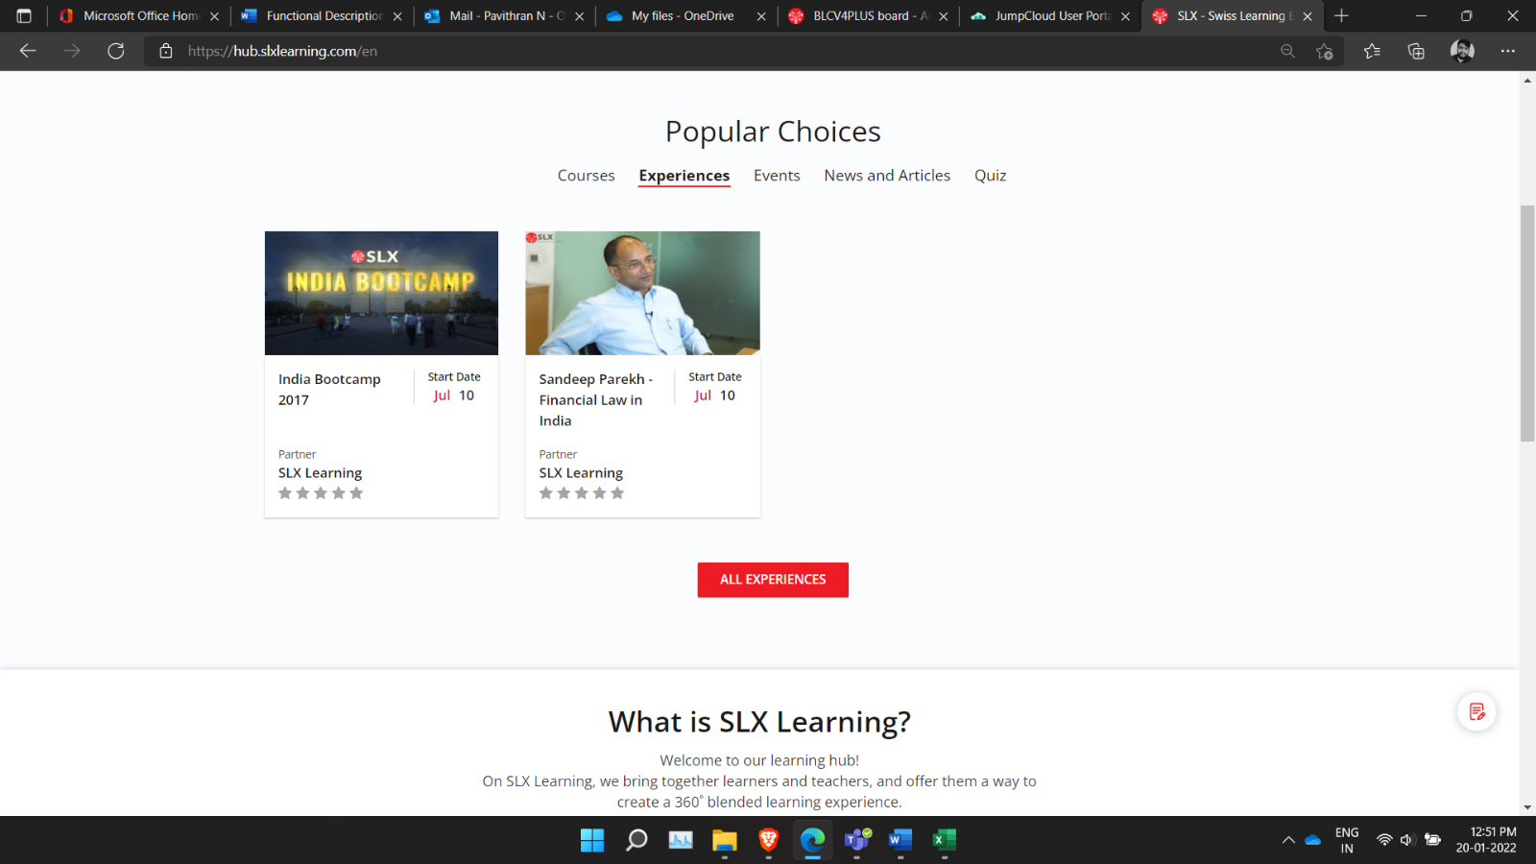

Figure 25

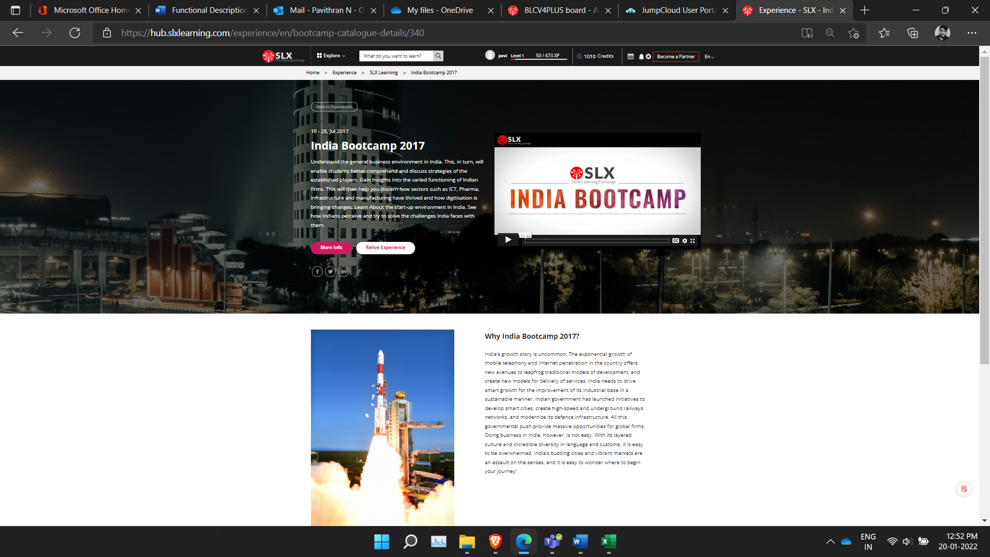

Figure 26

### Experience Registration Description:

User will be also able to check the experiences. Once user click on the all-experiences button users can see the all the given experiences. From their user ca select which ever experience they want. Their users can see the title and year, along with the start date. Here user also can check the partner and their rating in one to five.

Once user select any one experience, their user can go through brief description about it and can view demo video of it. Users also can share that experience through (Facebook, LinkedIn, and twitter). Since they are many types of experience users can use filters to select which kind experience they want. Here users can apply filters for all types of experience which include upcoming, past, current, and proposed. And in continuation can apply filters for partners, organization, credit range and range of distance. They are two more buttons given to the users, like more info and relive experience, which help the user to know about that experience and to relive it.

## QUIZ FLOW

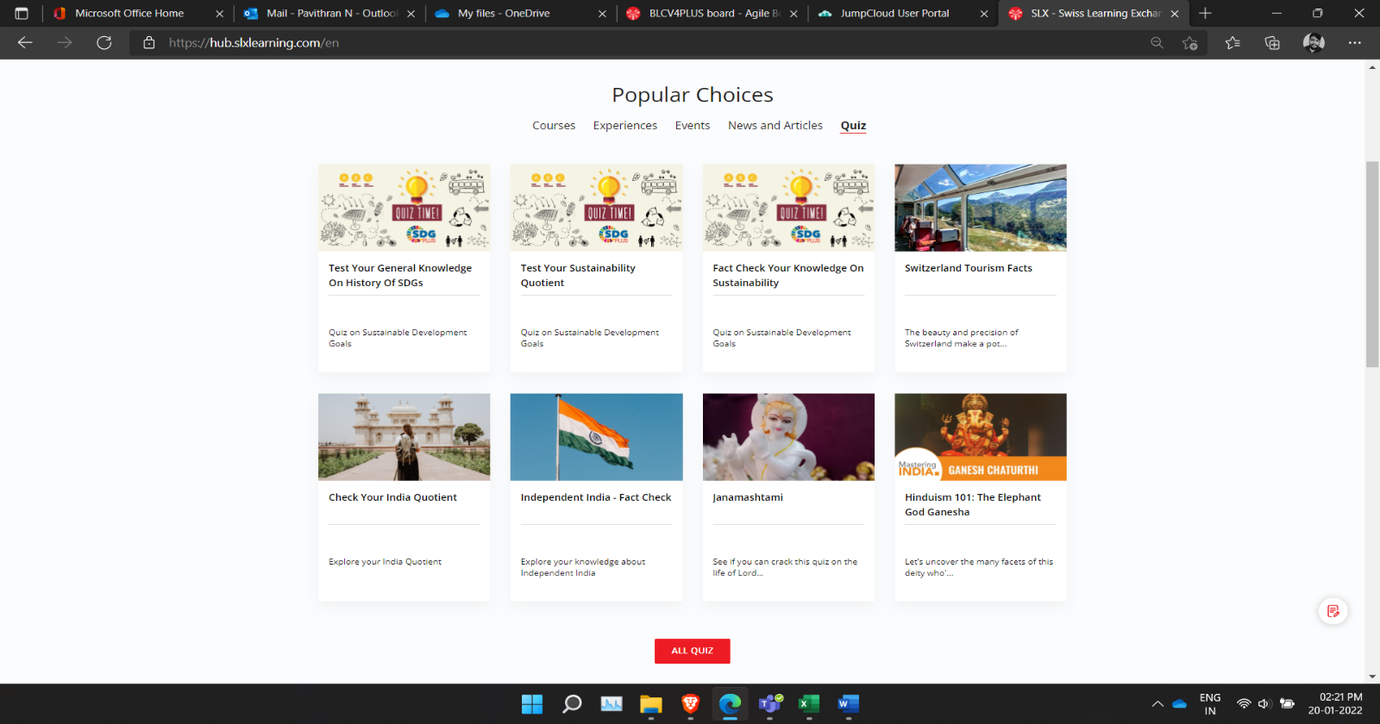

Figure 27

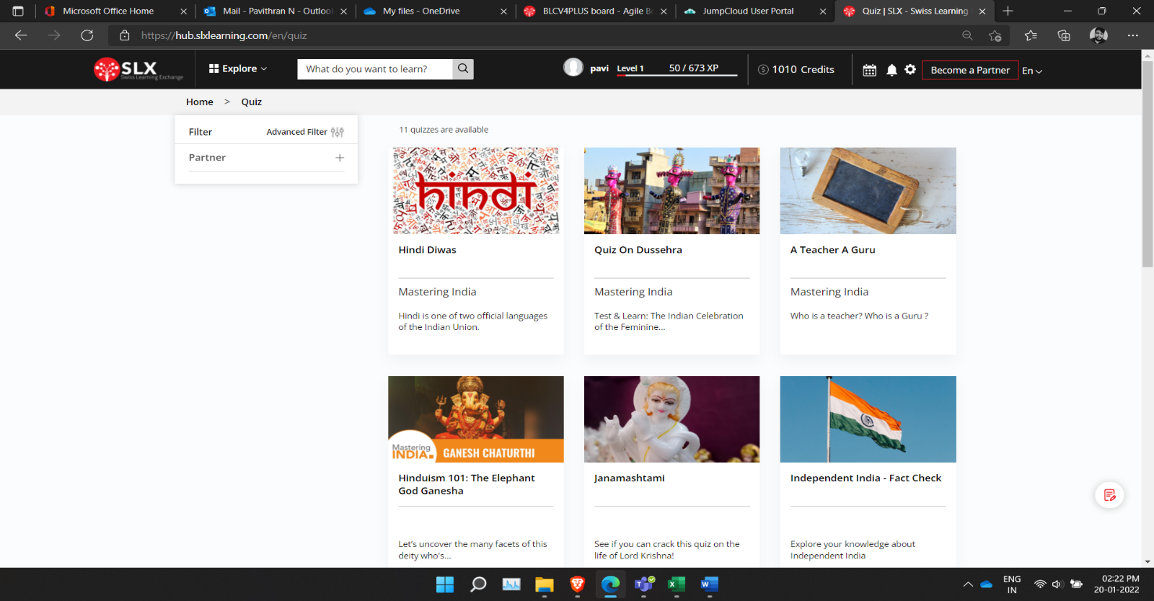

Figure 28

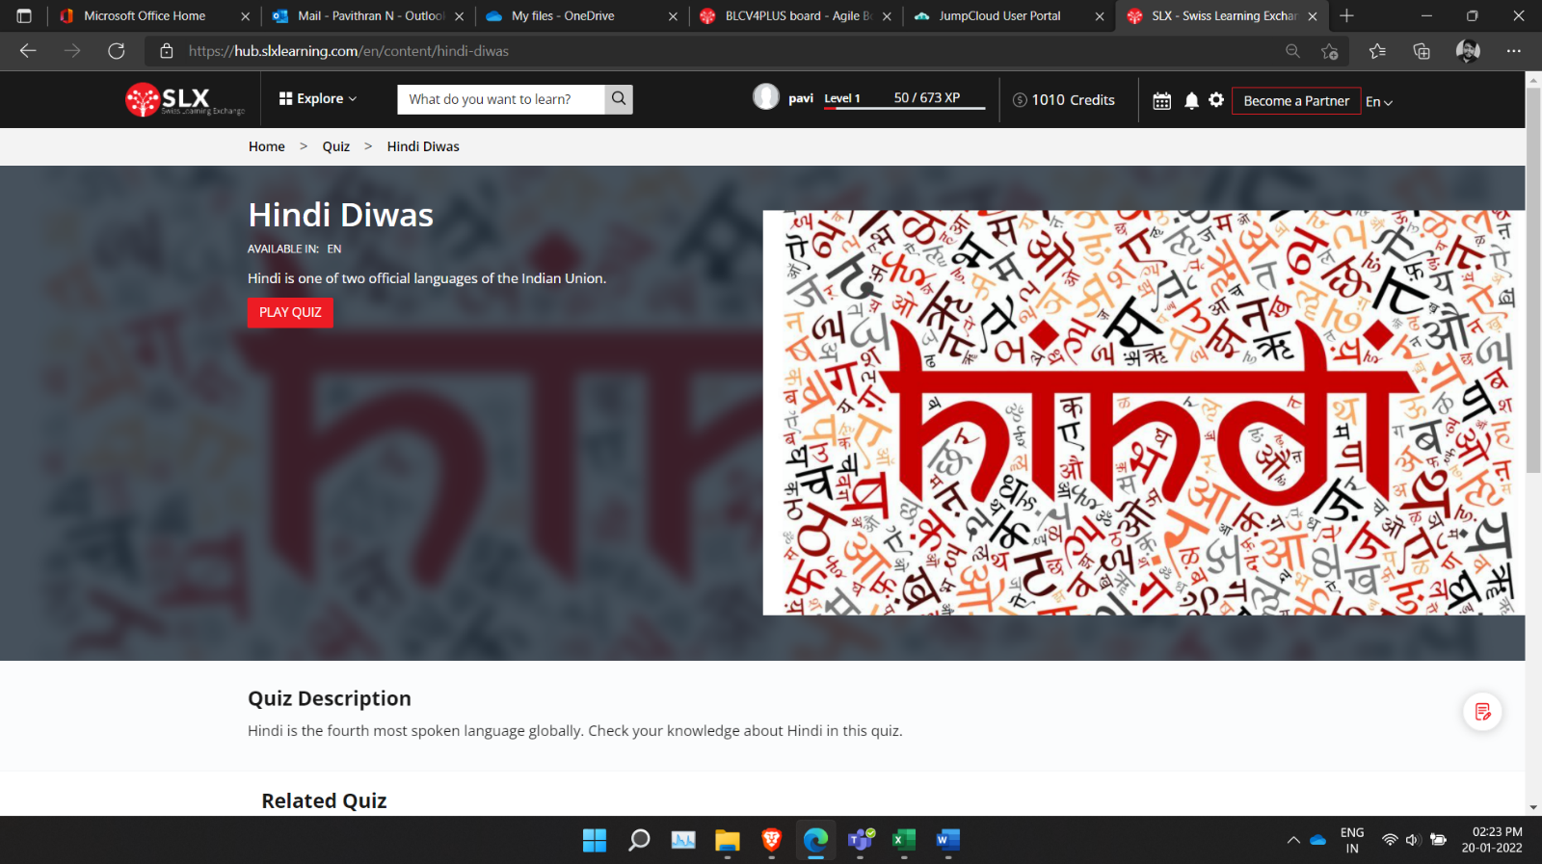

Figure 29

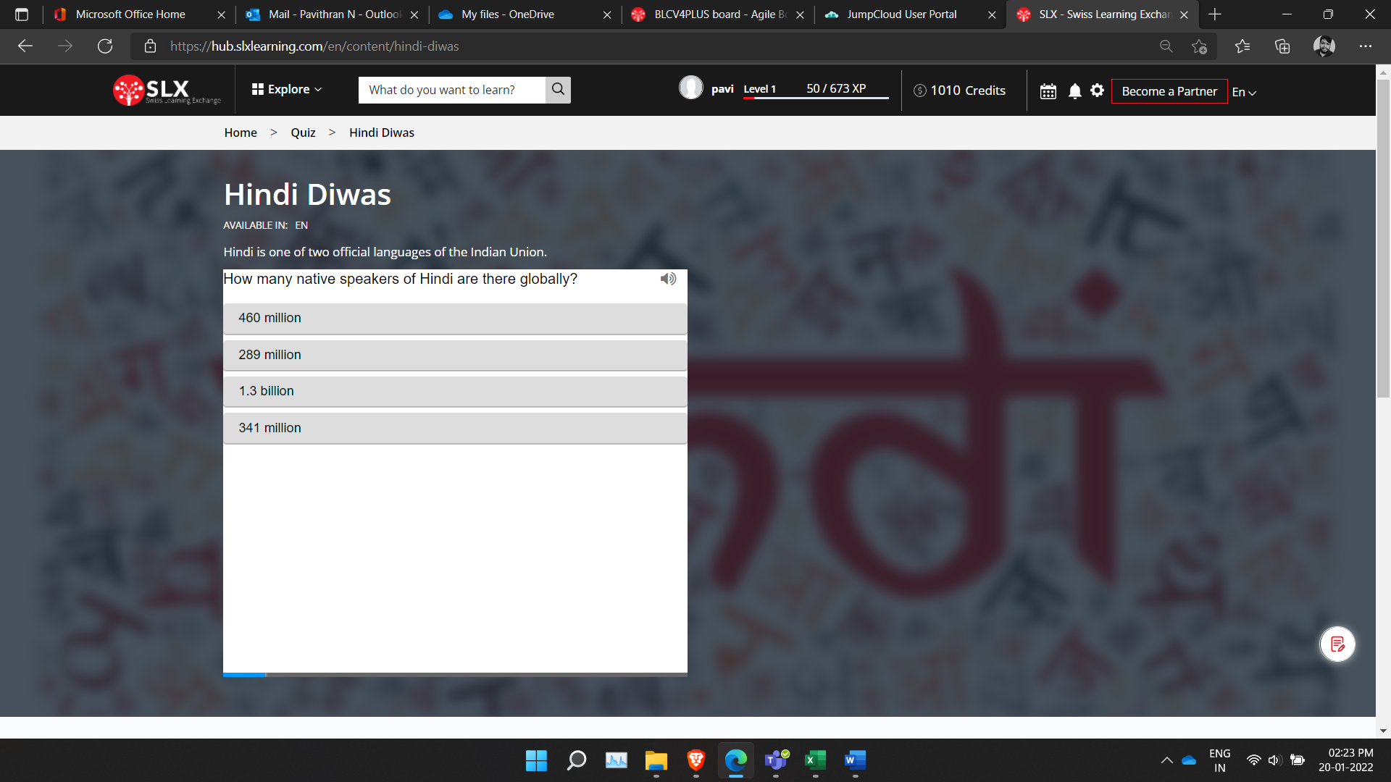

Figure 30

### Quiz Flow Description:

From popular choices in home user can select quiz module. Once user click on all Quiz button, it will take him to see all quizzes. From their user can choose which ever the quiz the user like. For each quiz title and partner name is provided. User can apply filter see the past, current and future courses. And user also allowed to apply on partners in given list to them.

Once they select one quiz, users are allowed to play quiz. And there will be 11 multiple choice questions to users. If user given right answer it will be shown in green, if not it will be shown in red. At the end of its user can see how much they scored. After that with the help of retry and show solution buttons, users can give retry for quiz and users can check the solutions.

# PARTNER ADMIN ROLE

## COURSE MODULE